202223 BUDGET ADJUSTMENTS

**202223 SCHEDULE B**

Budget & Reporting

Budget & Treasury Office

202223 SCHEDULE B

Table of Contents

PART 1 – ADJUSTMENTS BUDGET 5

1. Mayor’s Report 5

2. Resolutions 6

3. Executive Summary 7

PART 2 – SUPPORTING DOCUMENTATION 29

2.1 Adjustments to Budget Assumptions 40

2.2 Adjustments to Budget funding 40

2.3 Municipal Manager’s Quality Certificates 43

**Glossary**

**Adjustments budget –** Prescribed in section 28 of the MFMA.

The formal means by which a municipality may revise its annual budget during the year.

**Allocations –** Money received from Provincial or National Government or other municipalities.

**Budget –** The financial plan of the Municipality.

**Budget related policy –** Policy of a municipality affecting or affected by the budget, examples include tariff policy, rates policy and credit control and debt collection policy.

**Capital expenditure -** Spending on assets such as land, buildings and machinery. Any capital expenditure must be reflected as an asset on the Municipality’s balance sheet.

**Cash flow statement –** A statement showing when actual cash will be received and spent by the Municipality. Cash payments do not always coincide with budgeted expenditure timings. For example, when an invoice is received by the Municipality it is shown as expenditure in the month it is received, even though it may not be paid in the same period.

**DORA –** Division of Revenue Act. Annual legislation that shows the total allocations made by National to Provincial and local government.

**Equitable share –** A general grant paid to municipalities. It is predominantly targeted to help with free basic services.

**Fruitless and wasteful expenditure –** Expenditure that was made in vain and would have been avoided had reasonable care been exercised.

**GFS –** Government Finance Statistics. An internationally recognised classification system that facilitates like for like comparison between municipalities.

**GRAP –** Generally Recognised Accounting Practice. The new standard for municipal

accounting.

**IDP –** Integrated Development Plan. The main strategic planning document of the municipality

**MBRR –** Local Government: Municipal Finance Management Act (56/2003): Municipal budget and reporting regulations April 2009

**MFMA –** The Municipal Finance Management Act – No. 56 of 2003. The principle piece of

legislation relating to municipal financial management.

**MTREF –** Medium Term Revenue and Expenditure Framework. A medium term financial plan, usually 3 years, based on a fixed first year and indicative further two years budget allocations. Also includes details of the previous and current years’ financial position.

**Operating expenditure –** Spending on the day to day expenses of the Municipality such as salaries and wages.

**Rates –** Local Government tax based on the assessed value of a property. To determine the rates payable, the assessed rateable value is multiplied by the rate in the rand.

**SDBIP –** Service Delivery and Budget Implementation Plan. A detailed plan comprising quarterly performance targets and monthly budget estimates.

**Strategic objectives –** The main priorities of the Municipality as set out in the IDP. Budgeted spending must contribute towards the achievement of the strategic objectives.

**Unauthorised expenditure –** Generally, spending without, or in excess of, an approved budget.

**Virement –** A transfer of budget.

**Virement policy -** The policy that sets out the rules for budget transfers. Virements are normally allowed within a vote. Transfers between votes must be agreed by Council through an Adjustments Budget.

**Vote –** One of the main segments into which a budget. In Harry Gwala District Municipality means a directorate level.

# PART 1 – ADJUSTMENTS BUDGET

## Mayor’s Report

**INTRODUCTION**

The adjustment budget seeks to rectify issues identified in the mid-year assessment of the financial results as well as the inclusion of additional allocations. It is drafted in terms of section 28 of the MFMA and seeks to adhere to the stipulations of specifically section 28(2) of the MFMA

**BACKGROUND**

In accordance with section 28 of the Municipal Finance Management Act, No 56 of 2003 (MFMA) a municipality must revise its approved annual budget through an adjustments budget, in the following circumstances:

1. To appropriate additional revenues that have become available over and above those anticipated in the annual budget, but only to revise or accelerate spending programmes already budgeted for.
2. To authorise the utilisation of projected savings in one vote towards spending under another vote.
3. To authorise the spending of funds that were unspent at the end of the past financial year where the under-spending could not reasonably have been foreseen at the time to include projected rollovers when the annual budget for the current year was approved by the Council.
4. To correct any errors in the annual budget.

In line with the MFMA, the 2022/23 approved Budget has now been adjusted. The adjustment has been mainly necessitated as a result of the following:

* To appropriate the reduction of revenues that have been deducted from the annual budget, but only to revise spending programmes already budgeted for
* The need to authorise the spending of unspent funds at the end of the 2022/2023 financial year.
* The Adjustments Budget reaffirms the Municipality’s commitment to achieve the service delivery targets and performance indicators as reflected in the approved service delivery and budget implementation plan.

The process of budget adjustment also allows us to assess the state of our finances, reflect on the current challenges and design therapeutic measures that will turn around the finances of Harry Gwala District Municipality.

The attention is given to the department of Water Services operational efficiency with considerable emphasis on operations and maintenance cost control. The Water services budget has seen an increase by R 29, 8milllion due to the nature of the operations and maintenance undertaken under this department, while most departments have seen a decrease in their budgets.

In preparing the adjustment budget priority had to be given to Water Services Department by making budget available for the next five months, this is largely due to prioritization of repairs and maintenance of the aging water and sanitation infrastructure that is now degenerating putting more strain on the cash flow of the municipality.

## Resolutions

It is recommended that the Harry Gwala District Municipal Council;

* 1. Approves the adjustments budget and consolidated adjustments budget for the financial year 2022/2023, as set-out in the schedules contained in Section 4, be approved:
  2. Approves any adjustments permitted in terms of Section 28 (2) of the Act,
  3. Approves the revisions to the monthly and quarterly service delivery targets and performance indicators in the service delivery and budget implementation plan, if any, to correspond with the approval of the adjustments budget.
  4. Notes the Provincial Treasury comments and their effect on the Adjustments budget

## Executive Summary

The application of sound financial management principles for the compilation of the municipality’s financial plan is essential and critical to ensure that the municipality remains viable and that the municipality services are provided sustainably, economically and equitably to all communities.

It is critical to note that this report s28 MFMA report has been prepared as informed by the Midyear Performance assessment report presented to Council in January 2023 in terms of s72 of the MFMA a report that was also submitted to the National and Provincial in terms of s72 (1) (b) MFMA.

The Adjusted revenue has increased by R9, 2m (1%) from R865, 7m to R875m. This upward adjustment is mainly due to the following major contributing factors;

* Service charges - water revenue R 5, 4m
* Service charges - sanitation revenue R 1m
* Interest earned - external investments R 2, 2m
* Interest earned - external investments R 220k
* Dept of Higher Education R 313k
* Donnybrook Biomass R 1,3m

The Adjusted operations budget is R638, 1m having increased by R30, 3million from the original budget of R607, 8million. The item below had the major movements

* Decrease of R 5, 2m for Employee Related Costs
* An increase of R169k for Depreciation
* Increase of R24, 1m Contracted Services
* An increase of R 9, 6m for operational Costs

To this end much attention is given to the department of Water Services. Water services department also hosts the largest percentage of the municipality’s labour force. Water Services department seen an upward adjustment by R 29, 8million for operations and Maintenance.

The capital budget has decreased from R298, 1million to R295, 3million. This is mainly attributable to the downward adjustment of the following grants.

* Disaster Trucks R 2, 1m
* Installation of Smart Meters R 2,3m
* Land Acquisition R 1, 8m

As the municipality is in the process of reducing costs, there is an amount of R700 000 that is set aside to procure the mayor’s Vehicle, furthermore, the municipality decided not to renew the contract of leasing the municipal vehicles in that way the municipality is going save a lot of money.

**Budget Summary vs Adjusted Summary**

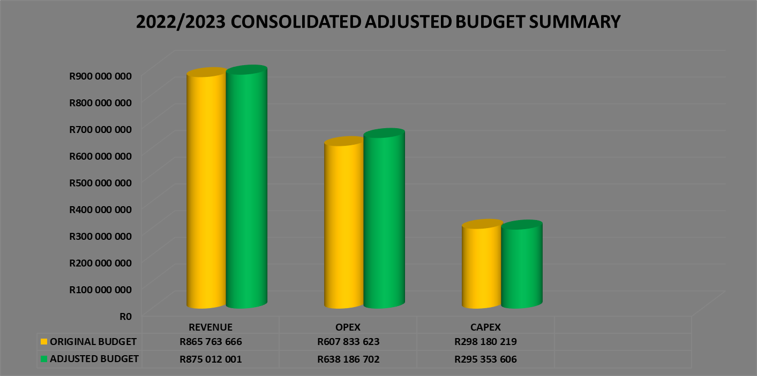

**TABLE B 1 CONSOLIDATED ADJUSTMENT BUDGET SUMMARY**

Table B1 below provides a summary of the budget adjustment of the municipality and is unpacked in the sections that follow.



**Table B1 Cont…..**



**TABLE B2 ADJUSTMENT BUDGET FINANCIAL PERFORMANCE**

Schedule B2 is the Expenditure by standard classification presents the adjustment expenditures by the departments.



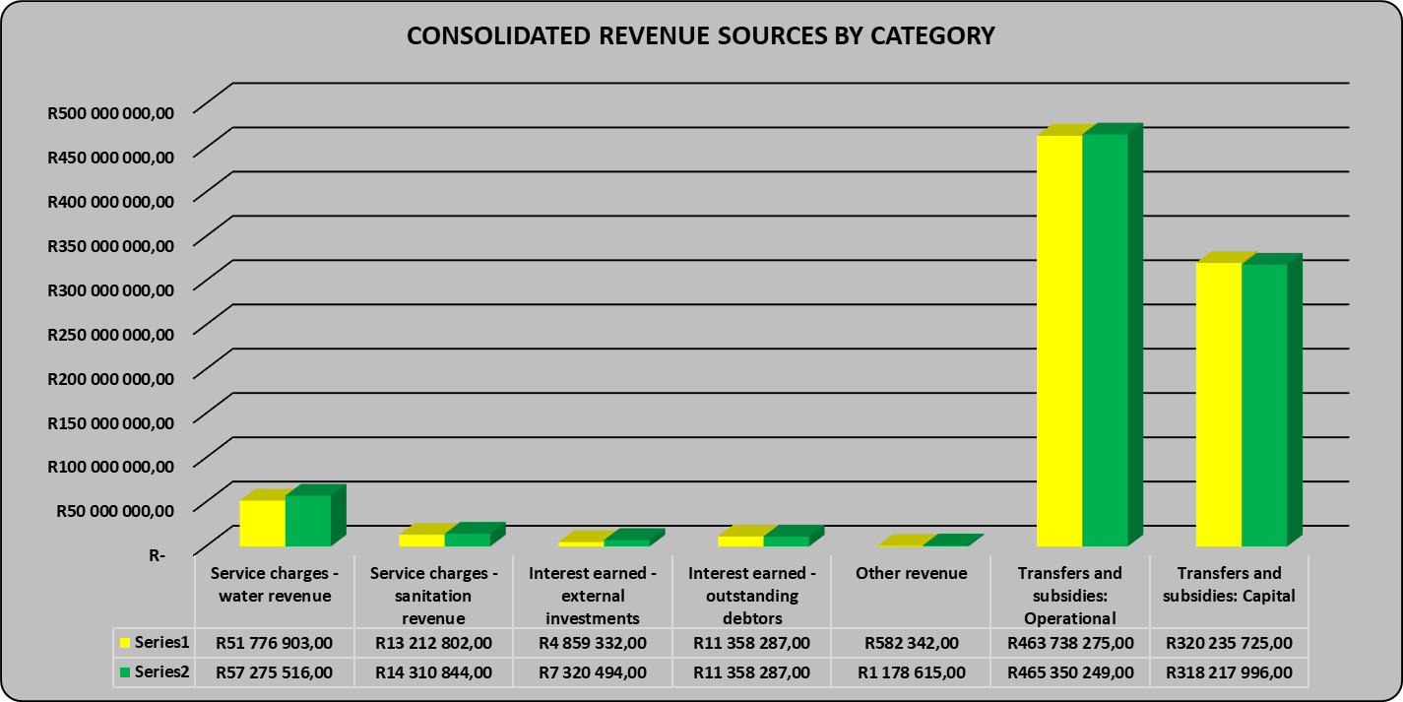

The consolidated revenue has increased by 1% from R865, 7million originally approved budget to R875million. This upward adjustment is mainly due to following major contributing factors;

* Service charges - water revenue: Increased by R5, 4million from R51, 7million to R57, 2million. An increase is as a result of prepaid consumption that is increasing due to billing that has been extended to extension 6 and 8 at uMzimkhulu. The revised revenue of R 57, 2million is 10% more than the original budget of R 51, 7million for the 2021/2022 financial year.
* Service charges - sanitation revenue: Adjusted upward by R1m from R13, 3million to R14, 3million. An increase is as a result of increasing due to billing that has been extended to extension 6 and 8 at uMzimkhulu.
* Interest earned - external investments: A positive variance of R 2.2 million or 34% due to Slow expenditure on capital expenditure on capital grants.
* Own revenue- A positive variance of R 596k or 51% due to increase in tender documents and clearance certificates.

**Chart 1: Adjusted Revenue Budget by Standard Classification**



Consolidated Operational expenditure has increased by 5% to R638, 1million. This increase is largely attributed to the water services department which is responsible for repairs and maintenance.

* Employee Related Costs: as. The revised employee-related costs expenditure of R 5, 2million or 2 percent less than the original budget of R 250million for the current financial year
* Contracted Services: A negative variance of R 24, 1 million or 21 percent due to limited funds therefore the original budget was underestimated. The revised budget includes upward adjustment of repairs and maintenance.
* Other expenditure or Operating Costs: A negative variance of R9, 6 million or 15per cent due to limited funds therefore the original budget was underestimated. The revised operating costs expenditure of R 9, 6million is 15 percent more than the original budget of R 64, 5million for the current financial year

**Chart 2: Adjusted Operation Budget by Standard Classification**

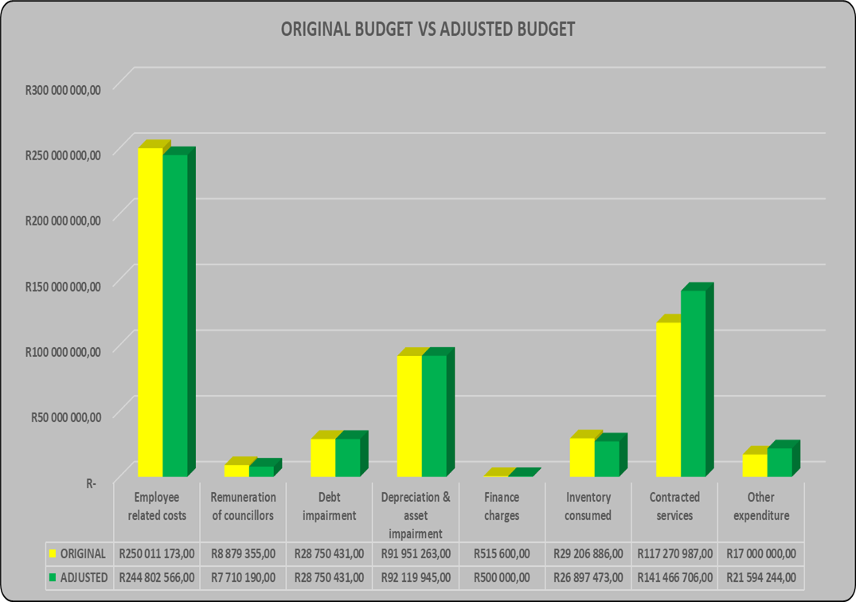

Some major differences above are caused by the cash flow constraint facing the municipality as a result of the limited revenue, while most departments have not adjusted their budgets, Water Services has seen an increase due to the nature of the operations and repairs and maintenance undertaken under water services department followed by Corporate Services due to day to day operations of the municipality. Water Services Department also hosts the largest percentage of the municipality’s labour force

**TABLE B3 ADJUSTMENT BUDGET FINANCIAL PERFORMANCE**

Table B3 presents the same information as the table above, the difference being that it’s by Municipal vote.



**Chart 3: Adjustment budget financial performance**

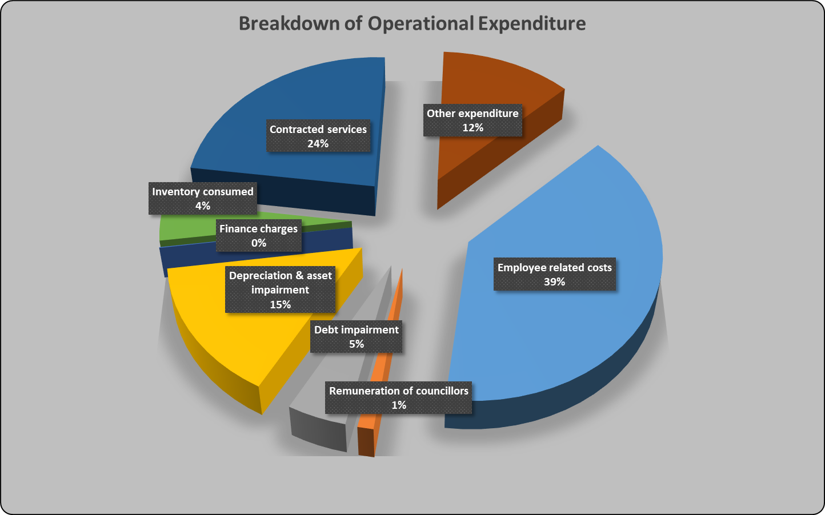

The graph above presents the adjustment budget expenditure by type.

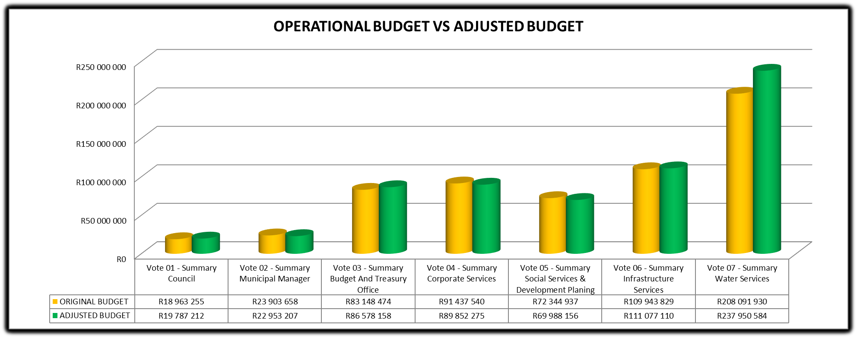

The graph above presents the adjustment budget expenditure by vote.

**TABLE B4 ADJUSTMENT BUDGET FINANCIAL PERFORMANCE**

This schedule provides information on the adjustment revenue by source and adjustment operational expenditures by type.



**TABLE B5 ADJUSTMENT CAPITAL EXPENDITURE BUDGET BY VOTE AND FUNDING**

Schedule B5 below reports on the adjusted capital expenditures by departments (municipal vote) and also by standard classification. The bottom part of the schedule looks at the funding sources of the capital projects.



**Chart 6: Capital Expenditure by Vote**

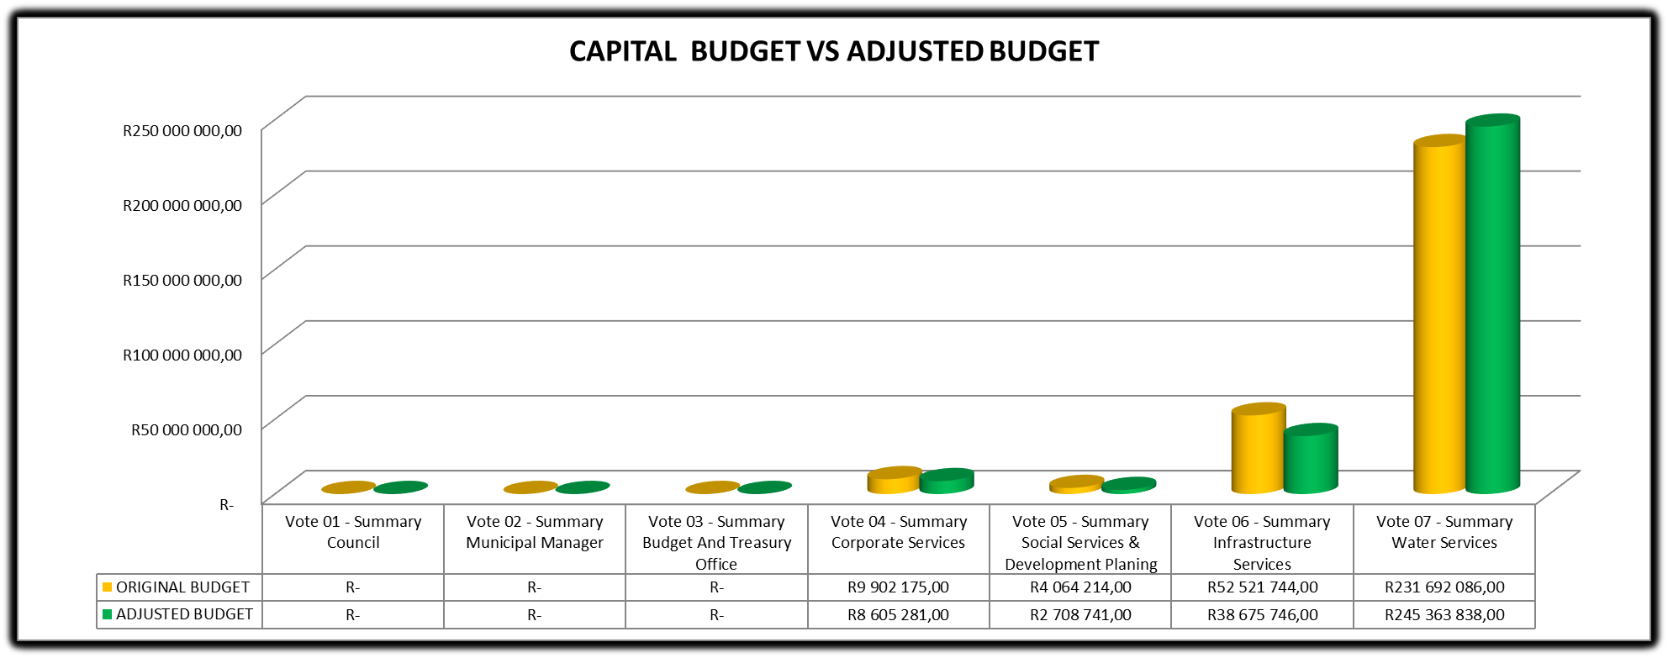

The capital budget has decreased from R298, 1million to R295, 3million. The municipality adjusted the budget downwards due to disaster trucks and installation of smart meters. A downward adjustment amounting to R2, 8million.The municipality put aside an amount of R1, 8 million for the acquisition of land.

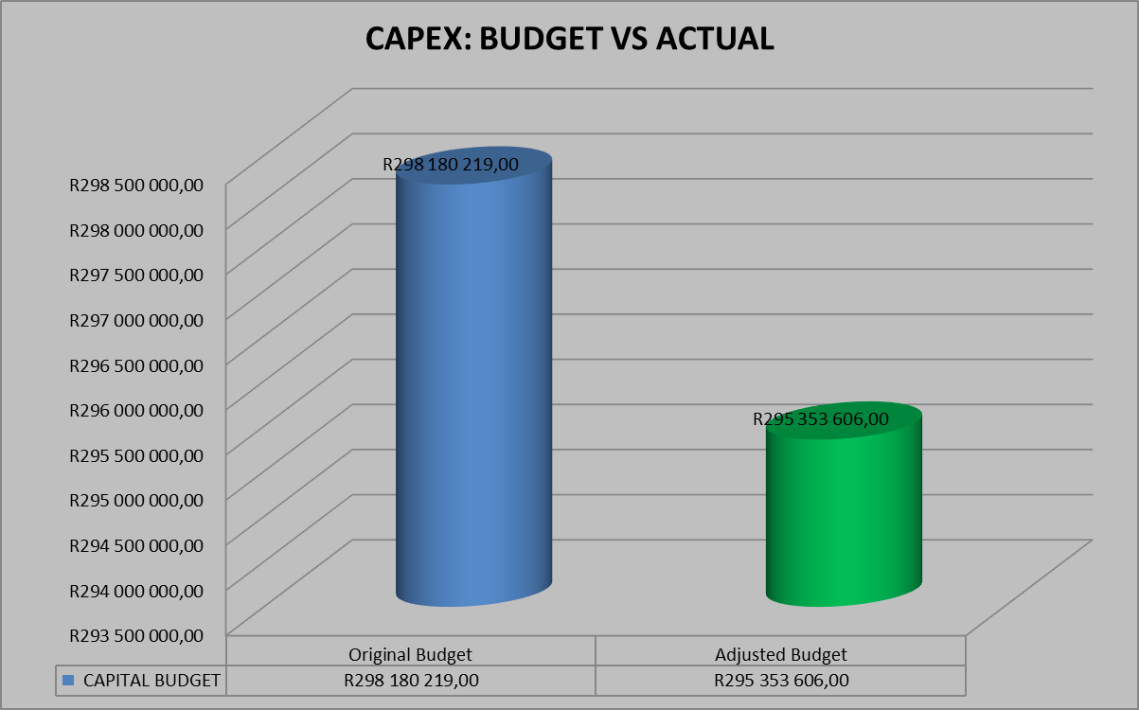

**TABLE B6 ADJUSTMENTS BUDGET FINANCIAL POSITION**

Table C6 displays the adjustment budget financial position of the municipality



**TABLE B7 ADJUSTMENTS BUDGET CASH FLOWS**



**TABLE B8 CASH-BACKED RESERVES / ACCUMULATED SURPLUS RECONCILIATION**



**TABLE B9 ASSET MANAGEMENT**





**TABLE B10 BASIC SERVICE DELIVERY MEASUREMENT**



**PARENT TABLES**

**TABLE B 1 PARENT ADJUSTMENT BUDGET SUMMARY**

Table B1 below provides a summary of the budget adjustment of the municipality and is unpacked in the sections that follow



# 

**TABLE B2 ADJUSTMENT BUDGET FINANCIAL PERFORMANCE**

Schedule B2 is the Expenditure by standard classification presents the adjustment expenditures by the departments.

# 

**TABLE B3 ADJUSTMENT BUDGET FINANCIAL PERFORMANCE**

Table B3 presents the same information as the table above, the difference being that it’s by Municipal vote

# 

**TABLE B4 ADJUSTMENT BUDGET FINANCIAL PERFORMANCE**

This schedule provides information on the adjustment revenue by source and adjustment operational expenditures by type



**TABLE B5 ADJUSTMENT CAPITAL EXPENDITURE BUDGET BY VOTE AND FUNDING**

Schedule B5 below reports on the adjusted capital expenditures by departments (municipal vote) and also by standard classification. The bottom part of the schedule looks at the funding sources of the capital projects.



**TABLE B6 ADJUSTMENTS BUDGET FINANCIAL POSITION**

Table C6 displays the adjustment budget financial position of the municipality



# TABLE B7 ADJUSTMENTS BUDGET CASH FLOWS



**TABLE B8 CASH-BACKED RESERVES / ACCUMULATED SURPLUS RECONCILIATION**

# 

**TABLE B9 ASSET MANAGEMENT**





# PART 2 – SUPPORTING DOCUMENTATION

## Adjustments to Budget Assumptions

There have not been major shifts in the budget assumptions. However, the few points noted below are work noting.

**External factors:** The economic slowdown as shown by the further declines in economic growth figures, the rising cost of living due to increases in the cost of borrowing and the high unemployment levels, financial resources are limited due to reduced payment levels by consumers. The latest figures released by the Census also show a decline in district population due to migration. This has resulted in declining cash inflows, which has necessitated major budgeted expenditure cuts to ensure that cash outflows remain within the affordability parameters of the district’s finances.

## Adjustments to Budget funding

Cash flow constraints still continue to affect the financial sustainability of the municipality as the municipality is largely grant dependent. This high grant dependency ratio (of over 93%) means that the municipality’s operations are highly sensitive to non-payment by consumers. The increasing water & sanitation infrastructural assets also tend to burden the operations budget in the form of high operations and maintenance costs.

Table SB 7 below provides details of the Government Grants and Subsidies differentiated between National & Provincial Governments.



The total adjusted **Operational Government** grant allocations are as follows;

* National Government R 465, 3million

The total consolidated adjusted **Operational Government** grant allocations are as follows;

* National Government R 465, 3million

While the adjusted **Capital Funding** are as follows;

* National Government R 320, 2million

## 

## Municipal Manager’s Quality Certificates

I**, Gamakulu Ma’art Sineke**, Municipal Manager of **Harry Gwala District Municipality**, hereby certify that the adjustments budget and supporting documentation have been prepared in accordance with the Municipal Finance Management Act and the regulations made under that Act, and that the adjustments budget and supporting documentation are consistent with the Integrated Development Plan of the municipality.

Print name: Gamakulu Ma’art Sineke

Municipal Manager of Harry Gwala District Municipality (DC43)

Signature: ___________________

Date 22 February 2023